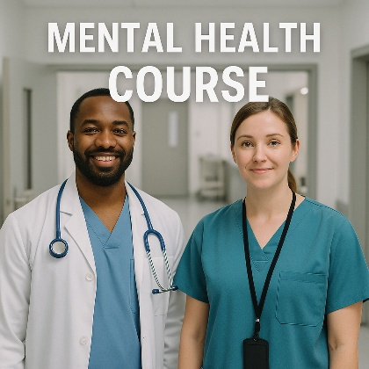

🔵 **Mental Health: Emergencies and interventions**

Learn to respond, assess, and manage psychiatric emergencies effectively

Offered by STC and BAULS

✅Required for Lebanese hospital accreditation and JCI

✅ For Nurses, Students, ED Clerks, Security

✅ Certified by Skills Development Council Canada and BAULS

Course details:

Dates: June 18 & 20, 2025

Venue: BAU – Beirut Campus - Hariri building, 6th floor

Time : 9 to 3pm

✅fees: 300 $ for individual registration

250 $ for BAU Alumni

250 $ per person for group registration

✅ Instructor: Hadi Chaya, BSN, MSN, Diploma in Addictology

Seats are limited ,for registration:

Mayyada.boumehdi@bau.edu.lb

[Traek.abdo8484@bau.edu.lb](mailto:Traek.abdo8484@bau.edu.lb)

Or call 009611300110 2892