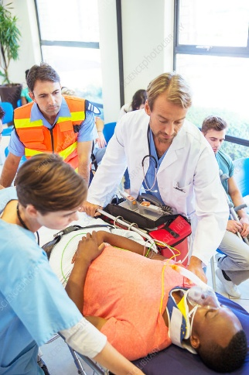

**BAU log BAULS Logo**

**EMERGENCY TRAUMA LIFE SUPPORT COURSE 🚑**  
**Be Ready to Save Lives When Every Second Counts!**

Objectives:

✅ Primary and Secondary Trauma Assessment  
✅ Airway Management and Breathing Support  
✅ Shock and Hemorrhage Control  
✅ Rapid Decision-Making for Trauma Care  
✅ Hands-On Practice with Expert Instructors

**Who Should Attend?**  
Doctors

Nurses

Paramedics,

First Responders

Medical / nursing Students

🎯 **Certification provided by BAULS with CME hours**  
🎯 **Small Class Sizes for Maximum Practice**   
🎯 **Latest Guidelines and Techniques**

🎯**Course duration: 2 days**

🎯**Fees: 250 for doctors**

**200 for nurses**

**Organized by:**  
Beirut Arab University Life Support Center

🔵 **Register Now! Limited Seats Available** 🔵  
     ✉️  [Mayyada.boumehdi@bau.edu.lb](mailto:Mayyada.boumehdi@bau.edu.lb)

[Tarekabdo8484@bau.edu.lb](mailto:Tarekabdo8484@bau.edu.lb)

📞 00961300110 x 2892

**Organized by:**  
Beirut Arab University Life Support Center