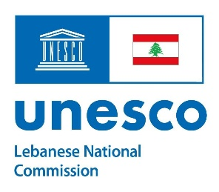
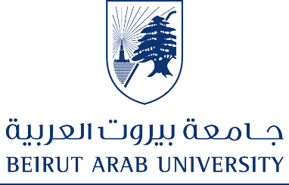

CERTIFICATE OF PARTICIPATION
awarded to
……………………………………………
for successfully participating in the training workshop on
Mediation and Human Rights Training for School Students: Focus on Children in Armed Conflict
organized by the Human Rights Center and the Faculty of Law and Political Science – Beirut Arab University, in collaboration with the Lebanese National Commission for UNESCO
Beirut Arab University on Saturday 13 December 2025

Dr. Omar Houri
Secretary General of Beirut Arab University & Director of the Human Rights Center
Ms. Amira Solh
Secretary General of the Lebanese National Commission for UNESCO

