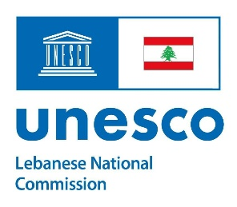
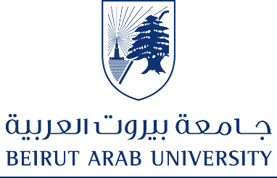

Training workshop on

Mediation and Human Rights Training for School Students:
Focus on Children in Armed Conflict

organized by the Human Rights Center and the Faculty of Law and Political Science – Beirut Arab University, in collaboration with the Lebanese National Commission for UNESCO

Beirut Arab University - Saturday 13 December 2025

