Advancing Research for a Sustainable Future Conference (ARSFC)
One-Day Conference | Beirut Arab University | June 9, 2026 | 9:00 AM – 4:00 PM | Venue: Jamal Abed el Naser Hall
9:00 – 9:30 | Opening Session | Theme: Research for a Sustainable Future  - Welcome Note:  - Session Moderator:  Ms. Dina Abou El Ez –Executive Research Administrator, Beirut Arab University  - Welcome Address:  Prof. Hania Nakkash – Dean of Graduate Studies & Research, Beirut Arab University  - Presidential Address:  Prof. Wael Nabil Abdel Salam – President, Beirut Arab University  - International Welcome Note:  Mr. Imran Riza – UN Deputy Special Coordinator for Lebanon  (or representative from WHO / UNDP / UNICEF)
9:30 – 10:00 | Keynote Address | Title: From Global Goals to Local Impact: Research as a Driver of Sustainable Futures  Keynote Speaker (one invited):  United Nations Representative nominated by Imran Riza
10:00 – 10:30 | Coffee Break & Networking
10:30 – 11:30 | Research Session I  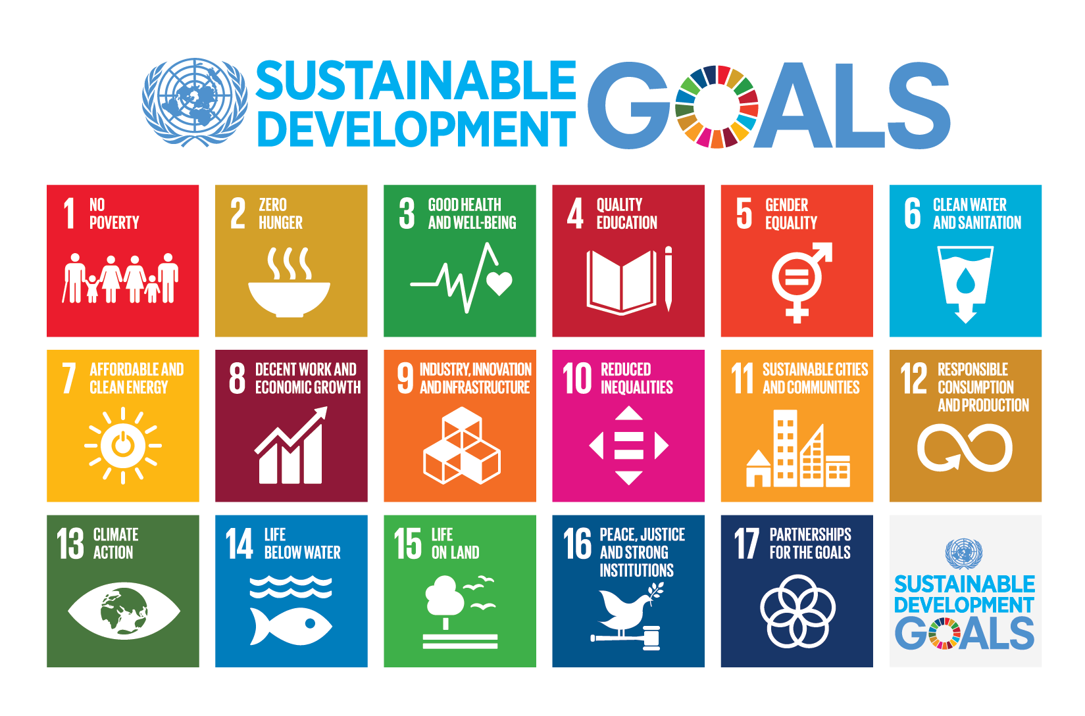 | One Sustainable Health  Focus: Digital health, resilient healthcare systems, innovation for wellbeing  - 3 research presentations (15 minutes each)  - Prof. Elie Akl - Vice Provost for Research at AUB  - Prof. Richard Maroun – Vice rector for research at USJ  - Prof. Rajaa Fakhoury – Dean of Faculty of Health Sciences, Beirut Arab University  - Session Moderator:  Prof. Said Shamieh- Professor of Human Statistical Genetics, Beirut Arab University
11:30 – 12:30 | Research Session II | Financial and Social Sustainability  Focus: Economic resilience, inclusive finance, social equity, governance  - 4 presentations (10 minutes each)  - Prof. Hanadi Taher – Professor of Economics, Beirut Arab University  - Dr. Ali Fakih – Associate Dean at the Adnan Kassar School of Business, LAU  - Prof. Hani El Chaarani – Professor of Finance & Business Sustainability-Director of Beirut Arab University (Tripoli Campus)  - Dr. Tala El Zein – Researcher in Social Policy & Governance- Associate Professor in business law  - Session Moderator: Dr. Maggie Houshaimi- Assistant Professor of Economics & Development Studies
12:30 – 1:30 | Lunch Break & Special Launch

Launch of the Youth Sustainability Club
- Club vision, mission, and objectives
- Youth leadership in sustainability research and action
- Call for student participation and collaboration
- Student and faculty ten-minute presentation
- Option of seeking FAO partnership for establishment
Featured Partner:
Arcenciel – Lebanese NGO for Sustainable Development & Social Inclusion
Session Moderators:
Prof. Nada El Darra – Professor - Head of Nutrition & Dietetics Department
Dr. Bilal Azakir – Associate Professor of Medical Biochemistry
1:30 – 2:30 | Research Session III  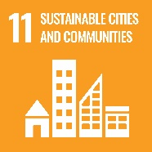 | Innovation for a Sustainable and Digital Future  Focus: AI, digital transformation, smart systems, future technologies  - 4 research presentations (10 minutes each)  - Prof. Jamal El Khatib – Professor of Civil Engineering at the Faculty Engineering  - Microsoft Representative – Regional Digital Innovation & AI Solutions Lead  - Prof. Abdallah Chakik – Professor of Computer Science & Applied AI  - Zaher Dawi – AUB Provost / or Imad El hajj – Professor of Electrical and Computer Engineering at AUB  - Session Moderator: Dr. Mohamad Ayache- Associate Professor of Biomedical Engineering
2:30 – 3:30 | Research Session IV | Climate-Resilient Communities & Urban Futures  Focus: Climate adaptation, urban resilience, sustainable cities  - 4 research presentations (15 minutes each)  - Ms. Ornella Nohra – UN Habitat  - Mohammad Al Hariri - Research and Development Manager Hariri Foundation for Sustainable Human Development  - Ghaleb Faour – Director at National Center for Remote Sensing (CNRS-Lebanon)  - Session Moderator: Hiba Mohsen -Associate Professor in Architecture
3:30 – 4:00 | High-Level Panel Discussion | Shaping a Sustainable Future: Challenges and Opportunities  - Moderator: Prof. Hania Nakkash  - Panelists (suggested):  - Director General of the Lebanese Ministry of Economy and Trade (Mohamad Abu Haidar)  - Director General of the Lebanese Ministry of Industry (Chantal Akl)  - Director General of the Lebanese Ministry of Health (Fadi Sannan)  - Director General of the Lebanese Ministry of Environment (Berj Hatjiam)  Guiding Themes:  - Research-driven sustainability  - Policy, finance, and social impact  - Youth as agents of change  - From national challenges to global opportunities  Panel Focus:  - Translating research into policy and practice  - Youth engagement and institutional responsibility  - Opportunities for Lebanon within global sustainability frameworks
4:00 | Closing Remarks | - Key outcomes and recommendations  - Future research directions at BAU  - Appreciation and acknowledgments
Potential Sponsors | Platinum Sponsors  (Strategic Lead Partners – Sustainability & Innovation Champions)  - Huawei  - UN Global Compact Network Lebanon  Gold Sponsors  (Major Institutional & Industry Partners)  - Blom Bank  - LGB  - Bank of Beirut  - Total Energies Marketing Lebanon  - CSR Lebanon  Silver Sponsors  (Supporting Corporate & Technology Partners)  - Whish Money  - Monty  - Clean Tech  - Equia Lebanon  - Best Assistance Insurance  Bronze Sponsors  (SMEs, Social Enterprises & Sustainable Businesses)  - Toters  - Plein Soleil  - Coral Oil & Liquigas  - Khan El Qaser  - Souk El Tayeb  - Issam Hashweh Bakery School  Community & NGO Partners  (Civil Society & Impact Organizations)  - Arcenciel  - Engineers Without Borders – Lebanon  - Amel Association International  - Kunhadi  - Toufoula  - Jouzour Loubnan
Potential Collaborations and Partnerships | - UN  - UNESCO  - WHO  - European Union  - CNRS  - AUF

