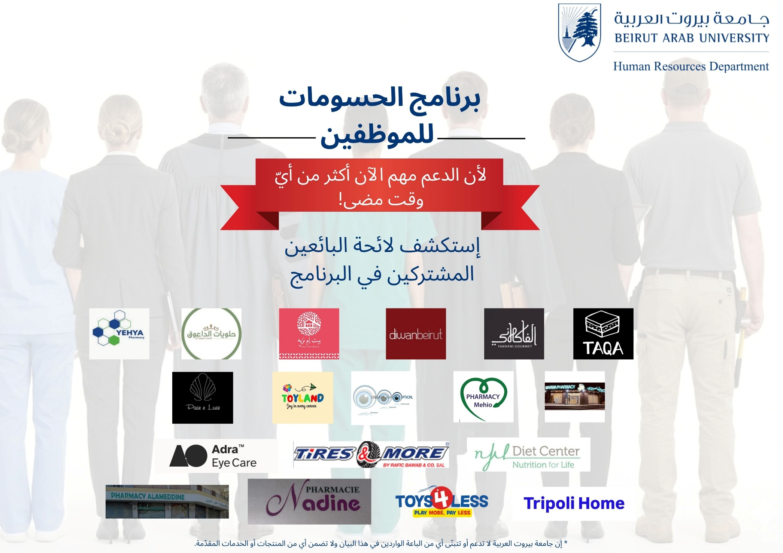
لأن الدعم مهم الآن أكثر من أي وقت مضى!

بالتزامن مع عيد العمال وابتداءً من أول أيار 2026، ستُتاح لأعضاء هيئة التدريس وللموظفين في جامعة بيروت العربية الاستفادة من حسومات تقدّمها مجموعة متنوعة واسعة من الباعة والشركات التجارية ضمن برنامج الحسومات للموظفين!
إن برنامج الحسومات للموظفين مقدّم من إدارة الموارد البشرية لجميع أعضاء هيئة التدريس وللموظفين امتناناً لما يبذلونه من جهود وعطاء في العمل.
يكفي إظهار بطاقتك الشخصية من جامعة بيروت العربية للحصول على حسم على المنتجات والخدمات من لائحة الباعة أدناه.
هذه مجرّد البداية، ترقبوا المزيد من الباعة والعروض في المستقبل القريب!
يرجى استلام بطاقاتكم التعريفية من إدارة الموارد البشرية اعتبارًا من يوم الاثنين الموافق 4 أيار 2026.
إنّ جامعة بيروت العربية لا تدعم أو تتبنّى أي من الباعة الواردة في هذا البيان ولا تضمن أي من المنتجات أو الخدمات المقدّمة. *

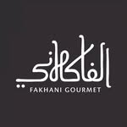

Fakhani Gourmet

Fakhani Gourmet will provide BAU staff and faculty with a 10 % discount on their products when they present their BAU Identification Card, at the following branches:

- Ras Nabeh: 76/714648
- Mar Elias: 01/305551
- Hamra: 81/463215
- Jnah: 01/855899
- Cornish el Mazraa: 78/777914
- Kantari :78/777924
- Dahye: 81/591374

Please note that this discount does not apply to already discounted items or special offers.
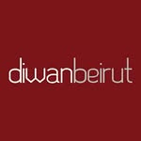

Diwan Mart

Diwan Mart will provide BAU staff and faculty with a 10 % discount on their products when they present their BAU Identification Card and Phone Number, on the following categories:
- Meat & Poultry
- ​Bakery
- ​Snacks
Branches:

- Tarik Al Jadida: 01/300370
- Nwairy: 01/668585
- ​Hamra: 01/352588
- ​Khalde: 05/810850
- ​Tripoli: 06/393993


University Optical

University Optical will provide BAU staff and faculty with a 20 % discount when they present their BAU Identification Card on Eye Glasses’ Frames and Sunglasses.

Address: Beirut, Tarik Al Jadida, facing BAU.
Phone Number: 01 704 638

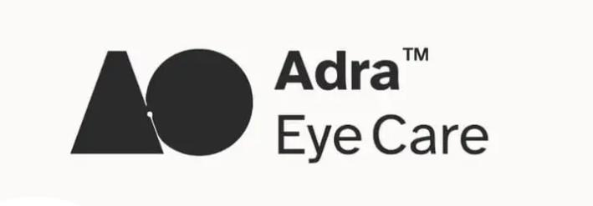

Adra Eye Care

Adra Eye Care will provide BAU staff and faculty with a 20 % discount when they present their BAU Identification Cards with the following:
- 10%-15% on Sunglasses
- 10% on Eyeglasses
- Special Bundles (including Eyeglasses lenses), to be specified on the spot depending on the prescription and visual needs.

Address: Tripoli, Maarad, Nadim El Jisr Street.
Phone Number: 06 213 752

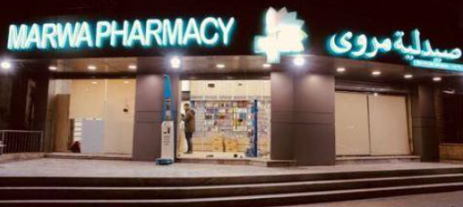
Marwa Pharmacy

Marwa Pharmacy will provide BAU staff and faculty with a 10 % discount when they present their BAU Identification Card on all para-pharmaceutical products including:
- Personal care products
- Skincare and cosmetics
- Baby products
- Hygiene products
- Oral care
- Medical devices and wellness items.

Address: Beirut, Cola Square.
Phone Number: 01 315 209
WhatsApp: 03 034 761
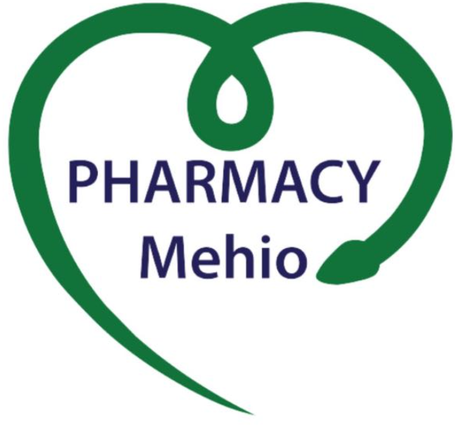

Mehio Pharmacy

Mehio Pharmacy will provide BAU staff and faculty when they present their BAU Identification Cards with the following:

- 20 % discount on Cosmetics
- 15% discount on supplements
- Free delivery in Beirut on all orders above USD 150

Address: Beirut, Tallet El Khayat, facing Tele Liban, near ABC Mall.
Phone Number: 01/786770
WhatsApp: 03 224 917



Nadine Pharmacy

Nadine Pharmacy will provide BAU staff and faculty when they present their BAU Identification Cards with the following:

- 20 % discount on the following products: personal care, skincare and cosmetics, baby products, hygiene products, oral care, and medical devices.
- 12% discount on vitamins and supplements.

Address: Tripoli, Maarad Street, near Liban Post.
Phone Number: 06/440470
WhatsApp: 78 886 656

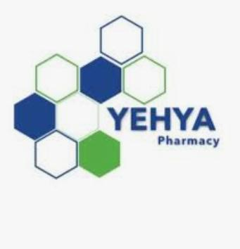

Yehya Pharmacy

Yehya Pharmacy will provide BAU staff and faculty an up to 15% discount on all cosmetics, dermocosmetics, vitamins and paramedical products faculty when they present their BAU Identification Cards.

Address: Tripoli, Corniche EL Mina, Near Beirut Arab University.
Phone Number: 03/006014
WhatsApp: 70 681 178

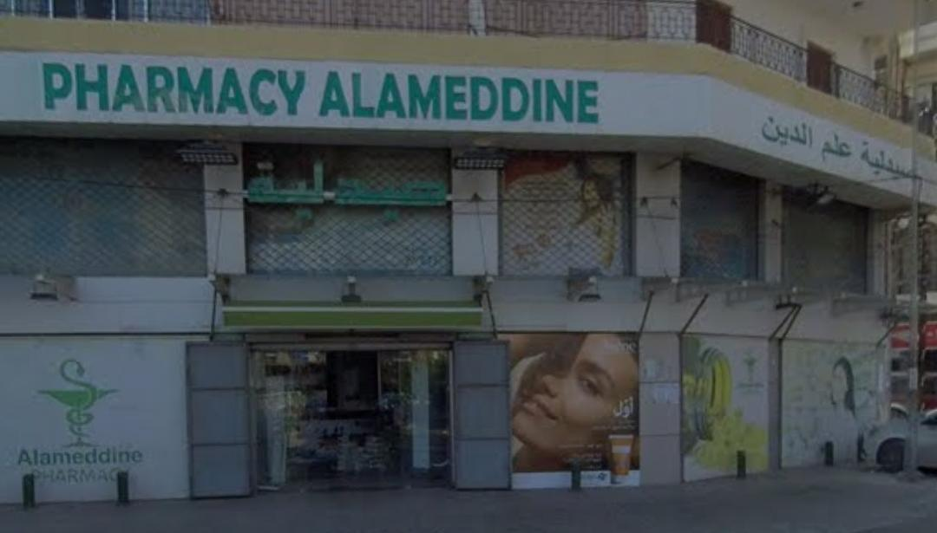

Alameddine Pharmacy

Alameddine Pharmacy will provide BAU staff and faculty when they present their BAU Identification Cards with the following:

- 15% to 20% discount on Cosmetics products like (Avene, Ducray, La Roche Posay, Eucerin, Beesline, Talika, Cetaphil, Vichy, SVR, Bioderma, Cerave, Klorane, Mustella, A Derma…)
- 15% discount on vitamins

Address: Tripoli, Zahrieh, Main Street.
Phone Number: 06/437 000
WhatsApp: 03/ 000 046


Tripoli Home

Tripoli Home appliances will provide BAU staff and faculty with a 30% discount on all small home appliances items e.g.: air fryer, hand blender, crepe maker machines, waffle maker machines, vacuums, coffee machines, stand mixers, electric ovens, microwaves, Hair dryers, straighteners, irons when they present their BAU Identification Cards.

Please note that this discount does not apply to large home appliances, specifically: televisions, refrigerators, washing machines, dishwashers, cooktops, ovens, hoods, air conditioners, water dispensers, and freezers.

Address: Tripoli, Bahsas.
Phone Number: 06 409 654


Tires & More

TIRES & MORE will provide BAU staff and faculty with a 15 % discount when they present their BAU Identification Cards in the following branches:

- Sanayeh: facing Sanayeh Garden (from the south) - 01/340888
- Khaldeh: facing Chamsine bakery - 05/801182
- Canal 7: Beirut, Canal 7 street - 01/811755
- Choueifat: Near Aramoun crossroad entrance - 05/811899
- Zalka: Zalka highway, near Mike sport - 01/888559 | 01/888557
- Mkalles: Mkalles main road, near Farra design - 01-690071/2
- On-Road Service: 03/000472

With the convenience of payment in four consecutive monthly installments for purchases exceeding $100.
Offer covers the following:

- European passenger car tires: Continental, Goodyear, Uniroyal (a brand of Continental), General Tire (a brand of Continental), and Nexen Europe
- Korean passenger car tires: Nexen and Roadstone
- Premium Thai passenger car tires: Otani
- Premium Chinese passenger car tires: Goodride, Three A, Aoteli, Rapid, and Minnell
- All kinds of automotive batteries
- All types of automotive oil, filters, lubricants, and wipers.

The offer is valid till 31/12/2026. Please note that this discount does not apply to already discounted items or special offers.
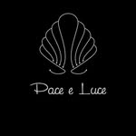

Pace e Luce

Pace e Luce hair salon will provide BAU staff and faculty with a 20 % discount when they present their BAU Identification Card on Hair & Make Up services.

Address: Verdun.
Phone Number: 01 355 554
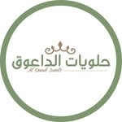
Al Daouk Sweets

Al Daouk Sweets will provide BAU staff and faculty with a 10 % discount on their products when they present their BAU Identification Card at the following branches:
- Tarik Al Jadida: 03/799755
- Aisha Bakkar: 70/919182
- Baalbak: 81/188241‬
- Chatura: 71/035805
- Najjarieh: 81/754954
- Zouk Mikael: 71/888920
- Dahye: 78/919182
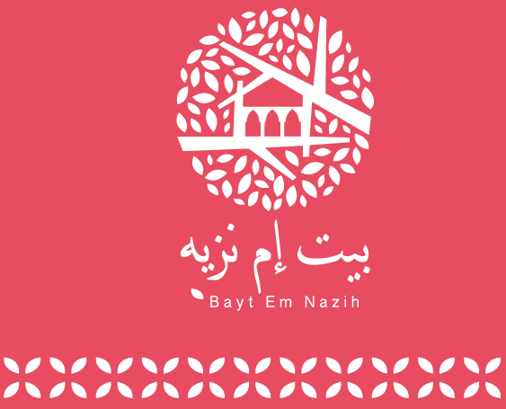

Bayt Em Nazih Restaurant

Bayt Em Nazih restaurant will provide BAU staff and faculty when they present their BAU Identification Cards with the following:

- 15% discount on food and beverages at Bayt em nazih.
- 15% Discount of Food and beverages at the pool deck entrance.

Address: Hamra.
Phone Number: 03/ 005 717

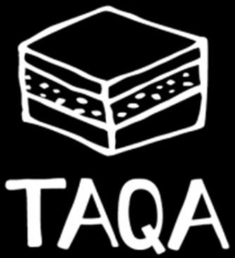

TAQA Healthy Cookies & Energy Bars

TAQA Healthy Cookies & Energy Bars will provide BAU staff and faculty 10% discount on all orders placed through their website.

Website: www.taqasnacks.com
Note: TAQA Snacks are Natural, Vegan, Wheat-Free, Yeast-Free, Palm Oil-Free, Corn-Free, Soy-Free and GMO-FREE.



Toys 4 Less

Toys 4 Less will provide BAU staff and faculty with a 10 % discount on their products (limited to an annual spending ceiling of $1,000) when they present their BAU Identification Card at the following branches:
- Verdun: 81/991 383
- Jnah: 71 / 815 020
- City Mall: 76/005 183
- Hazmieh: 71/916126
- Mkalles: 71/064925
- Mtayleb: 81/374 684
- Jbeil: 81/988381
- Jounieh: 81/ 412 786

Note: The discount is exclusively for in-store purchases and will not apply to online purchases, and does not apply to items that are already on sale or promotion.

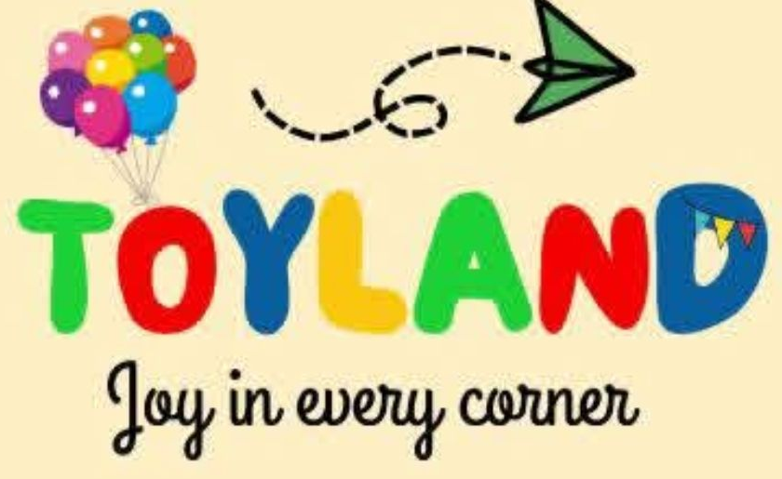
Toy Land

Toy Land will provide BAU staff and faculty with a 20 % discount on their toys and balloon services when they present their BAU Identification Card.

Address: Saida.
Phone Number: 03/ 632 856



Nfl diet Center

Nfl diet Center will provide BAU staff and faculty 10% discount on diet meal plans (14 Days Package).

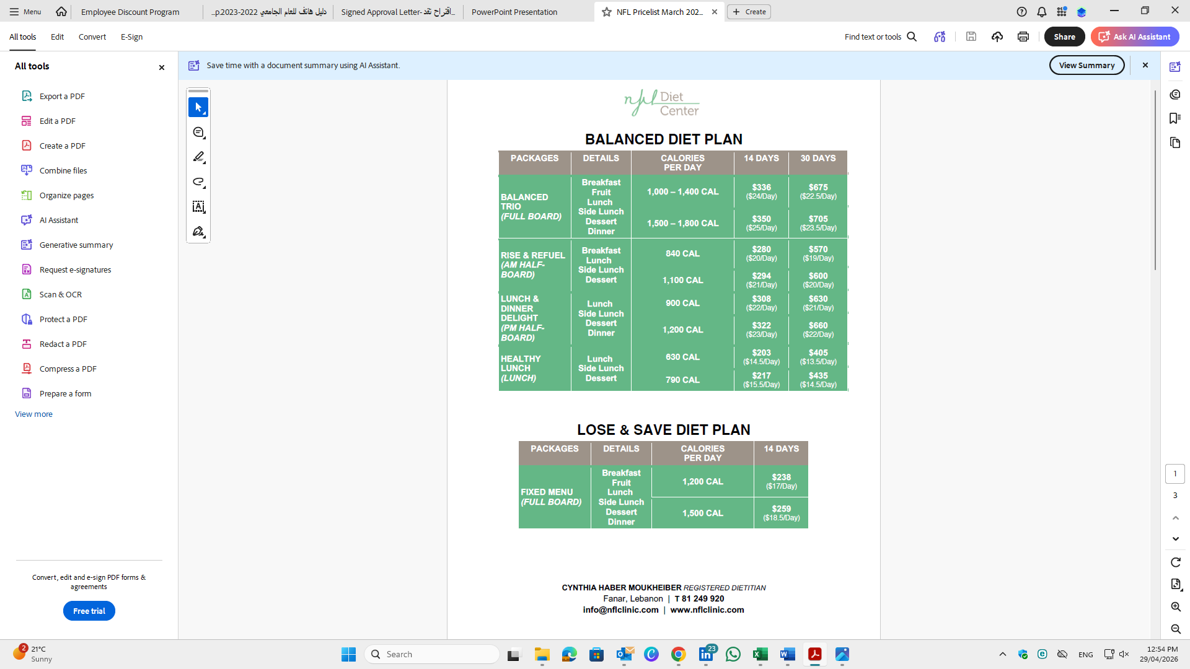
Phone Number: 81 249 920
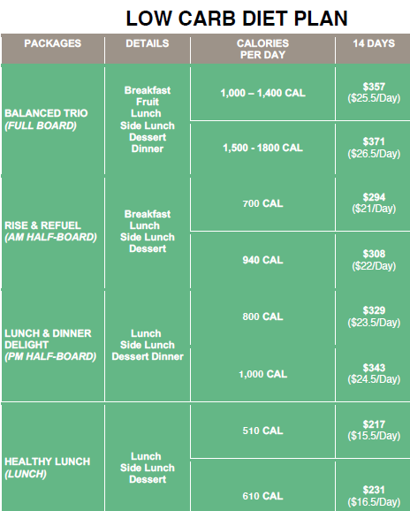
Website: www.nflclinic.com
Address: Fanar.
