CALL FOR PAPERS
 |  |  |  |  | 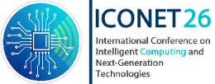 | 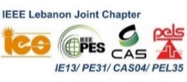 |  |  |  | 
International Conference on Intelligent Computing and Next-Generation Technologies
ICONET26
Beirut Arab University - Debbieh Campus - Lebanon
15-16 October 2026
Honorary Chair  Wael Nabil Abdel Salam, BAU, Lebanon  General Chairs  Yehya Temsah, BAU, Lebanon  Nazih Moubayed, LU, Lebanon  Walid Karam, AUT, Lebanon  General Co – Chairs  Ali Haidar, BAU, Lebanon  Layth Sliman, Research Professor, EFREI, France  Executive Director  Elio Aoun, Chedid Capital, Lebanon  Technical Program Chairs  Abdallah Kassem, NDU, Lebanon  Mohammad Ayache, BAU, Lebanon  Hiba Bazzi, BAU, Lebanon  Technical Program Vice Chairs  Abdallah El Ghali, BAU, Lebanon  Ahmad Fadlallah, USAL, Lebanon  Chady Abou Jaoudeh, Antonine, Lebanon  Chantal Hajjar, USJ, Lebanon  Hiba AL-Sheikh, CITYU, Lebanon  Imad Jawhar, MU, Lebanon  Josef Zaraet, USEK, Lebanon  Mohammad Diab, RHU, Lebanon  Mohammad Rahal, AUST, Lebanon  Nadine Abbas, LAU, Lebanon  Walid Fahs, IUL, Lebanon  Digital Infrastructure Chair  Mustafa El Bizri, BAU, Lebanon  Publication Chairs  Alaa Daher, BAU, Lebanon  Iman Haidar, BAU, Lebanon  Kassem Danach, MU, Lebanon  Mustafa Hamad, NDU, Lebanon  Rima Kilani, USJ, Lebanon  Industrial Relation Chairs  Julie Budaher, BAU, Lebanon  Ousama Dankar, BAU, Lebanon  Yousef Bakouny, USJ, Lebanon  Ziad Doughan, BAU, Lebanon  Finance Chairs  Abdul Rahman El Falou, BAU, Lebanon  Hiba Halabi, BAU, Lebanon  Manal Fattoum, BAU, Lebanon  Roy Abi Zeid Daou, ULS, Lebanon  Plenary Session Chairs  Hamzah Issa, BAU, Lebanon  Mohamad Tarnini, BAU, Lebanon  Ousama Mustapha, RHU, Lebanon  Youssof Traboulsi, BAU, Lebanon  Media Committee Chair  Ghina El Waly, BAU, Lebanon  Marianne Abi Kanaan, Antonine, Lebanon  May Itani, BAU, Lebanon  Rouaa Alchamaa, RHU, Lebanon  Rodayna Hmede, IUL, Lebanon  Publicity Chair  Abdallah Al Sabbagh, BAU, Lebanon  Hassan Harb, AUM, Kwait  Majeed AbdelRahman, BAU, Lebanon  Samar Sindian, MU, Lebanon  Youssef Ajra, BAU, Lebanon  Local Arrangement Chairs  Amira Zaylaa, BAU, Lebanon  Mahmoud Skafi, BAU, Lebanon  Sereen El Hariri, BAU, Lebanon  Scientific Committee  Abed Ellatif SAMHAT, LU, Lebanon  Ahmad EL HAJJ, AUB, Lebanon  Badis HAMMI, Telecom, France  Charbel FARES, USEK, Lebanon  Diogo Menezes FERRAZANI MATTOS, UFF, Brazil  Fathelalem Ali HIJA, Joaan Bin Jasim Academy for Defense Studies, Qatar & Meio University, Japan  Gheith Ali ABANDAH, UJ, Jordan  Giuseppe FENZA, UNISA, France  Hadi KANAAN, USJ, Lebanon  Jean-Philippe MONTEUUIS, Qualcomm, USA  Lyes KHOUKHI, CNAM, France  Mohammed El-Hajj, AOU, Lebanon  Mohammed ODEH, West of England, UK  Mohamad SAWAN, Westlake Uni, China  Mutaz A.B. AL-TARAWNEH, AUM, Kwait  Rida KHATOUN, Telecom, France  Sandy RIHANA, USEK, Lebanon  Semaan GEORGES, NDU, Lebanon  Sobhi ABOU CHAHINE, BAU, Lebanon  Rochdi MERZOUKI, Lille, France  Ziad OSMAN, BAU, Lebanon |  | 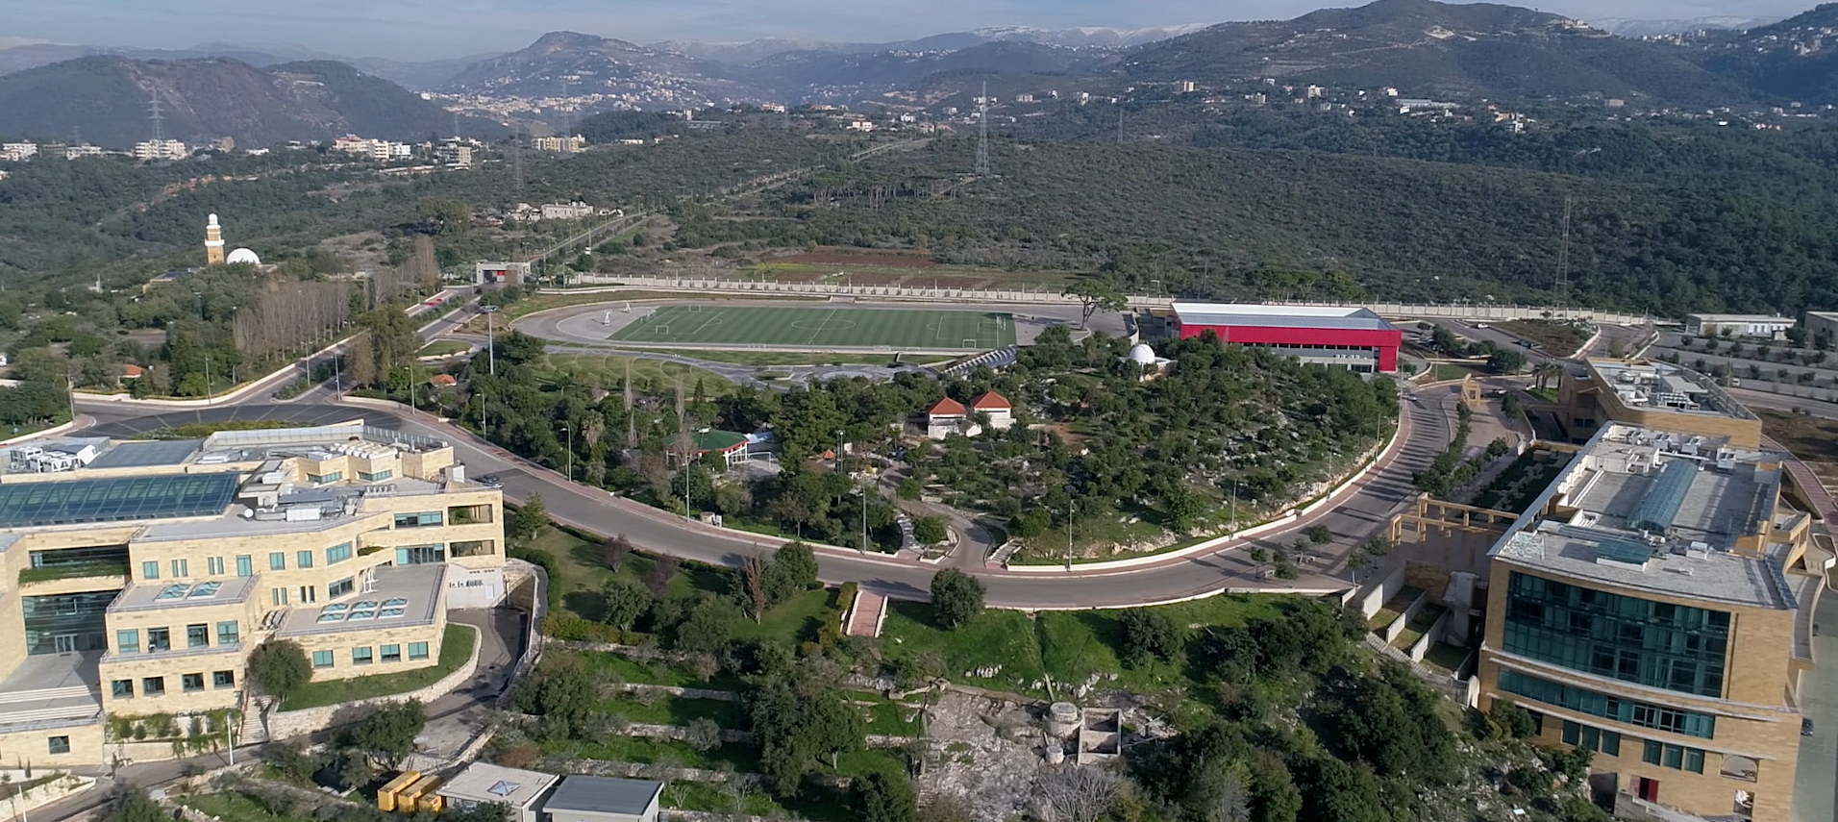  The International Conference on Intelligent Computing and Next-Generation Technologies (ICONET26) is a scientific venue dedicated to sharing advances in computing, intelligent systems, and next-generation communication technologies. It brings together researchers, academics, and industry professionals to present original research, exchange knowledge, and explore emerging trends in areas such as artificial intelligence, network architectures, cybersecurity, and cloud and edge systems. ICONET26 will feature advanced research presentations by invited keynote speakers in computer engineering. This conference is the official scientific event of the IEEE Computer Society Lebanon Chapter and will be hosted in 2026 by the Faculty of Engineering at Beirut Arab University, Lebanon. The conference will run for two days, and all submitted papers will undergo a peer-review process. Accepted and presented papers will be submitted for potential inclusion in IEEE Xplore. ICONET26 aims to foster collaboration, support research excellence, and contribute to shaping the future of connected and intelligent technologies.
 |  | LOCATION
 |  | ICONET26 will be held at Beirut Arab University - Debbieh Campus; it is located 33 km from Beirut city.
 |  | TOPICS
 |  | AI, Machine Learning, Data Science, Explainable AI (XAI), and Ethical AI Systems  Software Systems and Edge/Fog/Cloud Computing  Autonomous Systems and Robotics  Next-Generation Networks: 5G, 6G, and Beyond  Intelligent and Software-Defined Networks  Non-Terrestrial and Space Networks  IoT, Cyber-Physical, and Healthcare Systems  Smart Grid and Sustainable Energy Systems |  |  |  |  | Biomedical Engineering and Health Technologies  Green Networking and Power Management  Network Security and Privacy  Cybersecurity, Privacy, and Trusted Intelligent Computing Systems  Post-Quantum and Quantum-Safe Communications  Blockchain and Distributed Trust Systems  Emerging Communication Technologies  Standards, Ethics, AI Governance, and Digital Transformation
 |  | PAPER SUBMISSION
Authors are invited to submit papers in PDF format using the IEEE conference template. The paper template can be downloaded from the following website: https://www.ieee.org/conferences_events/conferences/publishing/templates.html
All papers must be submitted electronically via EDAS: https://edas.info/N35152
Questions regarding paper submission should be directed to: akassem@ndu.edu.lb, h.bazzi@bau.edu.lb, elio.aoun@ieee.org
Accepted papers, for which at least one author has completed registration and presentation requirements, will be submitted for potential inclusion in IEEE Xplore. Authors of selected papers presented at the conference will be invited to prepare an extended version of their work for possible publication in the BAU Journal – Science and Technology.
 |  | REVIEW PROCESS
 |  | The evaluation of submitted papers is based on technical merit, novelty of the approach, soundness of the results, and clarity of presentation are also considered as part of the evaluation process. Each paper will be fully reviewed by a minimum of two expert referees.
 |  | KEYNOTE LECTURES AND INVITED SESSIONS
 |  | The Program Committee is also soliciting proposals for invited sessions in one of the above theme areas. Interested organizers are invited to contact us at: akassem@ndu.edu.lb | h.bazzi@bau.edu.lb | elio.aoun@ieee.org
 |  | CONTACT
Abdallah Kassem | Email: akassem@ndu.edu.lb
Hiba Bazzi | Email: h.bazzi@bau.edu.lb
Elio Aoun | elio.aoun@ieee.org
 |  | IMPORTANT DATES
 |  |  |  | Full Paper Submission: July 1st, 2026 August 10th, 2026  Notification of acceptance: August 25, 2026  Camera Ready Submission: September 10th, 2026
https://events.bau.edu.lb/ICONET26

